Get NO2 data, visualize and export as csv.

https://ja.firstlightsalon.in/gis_threads/questions/376599/google-earth-engine-timeseries-chart

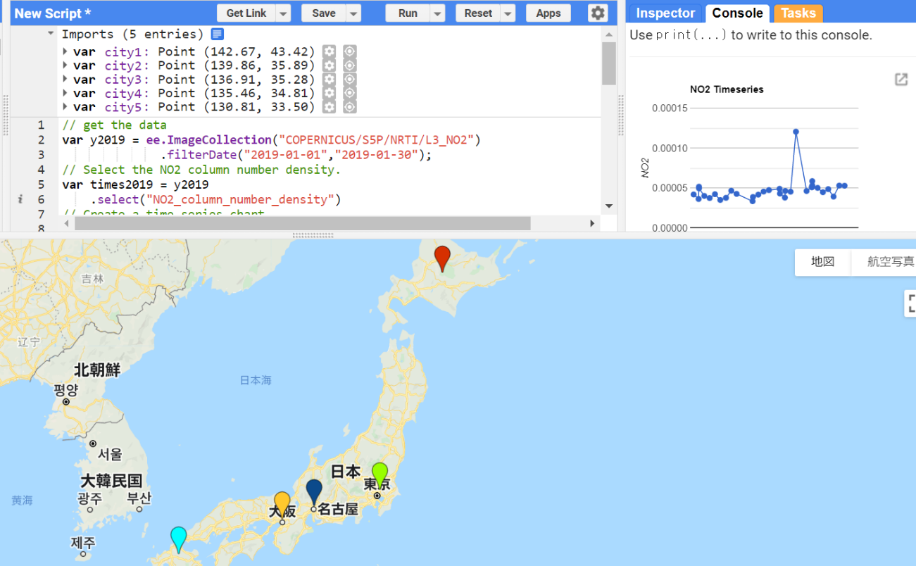

imports

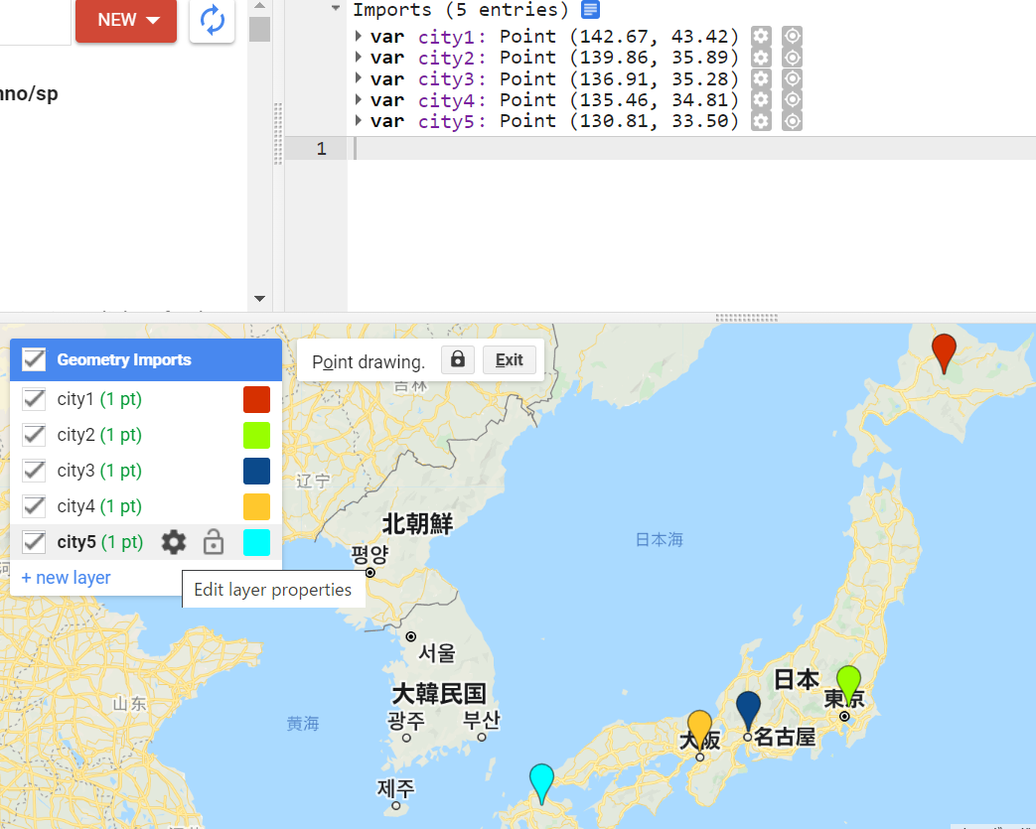

// get the data

var y2019 = ee.ImageCollection("COPERNICUS/S5P/NRTI/L3_NO2")

.filterDate("2019-01-01","2019-01-30");

// Select the NO2 column number density.

var times2019 = y2019

.select("NO2_column_number_density")

// Create a time series chart.

var TimeSeries = ui.Chart.image.seriesByRegion(

times2019, city1, ee.Reducer.mean(), "NO2_column_number_density", 200, 'system:time_start', 'label')

.setChartType('ScatterChart')

.setOptions({

interpolateNulls: true,

title: 'NO2 Timeseries',

vAxis: {title: 'NO2'},

lineWidth: 1,

pointSize: 4,

series: {

1: {color: '0000FF'}

}});

// Display.

print(TimeSeries);

// filter to region

var filtCol = times2019.filterBounds(city1);

// export to CSV

var data = ee.FeatureCollection(filtCol.map(function(image){

return ee.Feature(null, image.reduceRegion(ee.Reducer.mean(), city1, 200))

.set('system:time_start', image.get('system:time_start'));

}));

print(data)

// export directly as CSV

Export.table.toDrive({collection: data,

description: 'YOURDESCRIPTION',

fileFormat: 'CSV',

selectors: ['NO2_column_number_density', 'system:time_start']})